How to make a macrame plant hanger – to add greenery to your home
By the end of this 'how to' you will have made one of these lovely plant hangers!
The 70s knot is hot once more, with macramé plant hangers all over Instagram.
Learn how to make your own simple DIY macrame plant hanger. This simple project is a fun way to add more greenery and life to your space.
How to make a macrame plant hanger
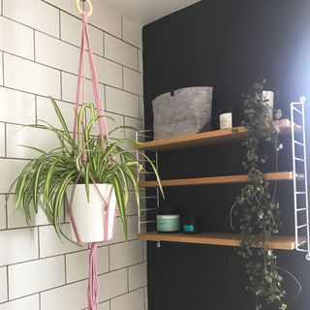
To get started, you’ll need the following materials:
- 4 x 2m cords (78.8 inches)
- 2 x 50cm cord (19.7 inches) – for the wrapped knot at top of the hanger
- 1 x wooden ring
1. Create the wrapped knot
Fold the 4 x 2m length cords evenly in half and thread the wooden ring to the centre point.
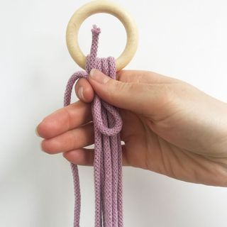
Take a 50cm piece of cord and make a loop at one end. Hold the loop against the longer lengths, close to the ring and with the loop facing down.
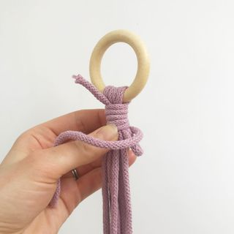
Wind the longer end of the looped cord around the bunch, starting at the top and working down.
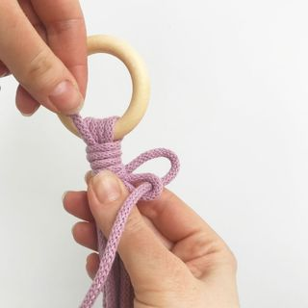
2. Make the basket
Hang your hanger back on the rail.
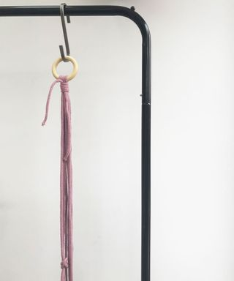
Take 2 cords, adjacent to one another and tie a knot approximately halfway down from the wrapped knot.

Repeat this with each pair of adjacent cords lengths.
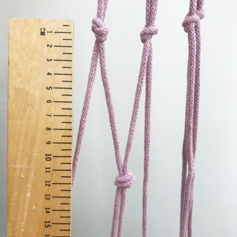
Now make another row of knots approximately 12cm away from the first set of knots. This time tie the alternate pairs of cord.
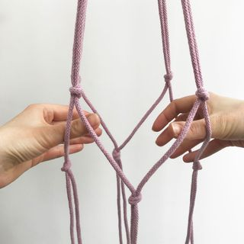
You’ll see the basket starting to take shape!
3. Finish it off!
Repeat the wrapped knot 12cm below the bottom row of knots using the remaining 50cm piece of cord.

Now, try out a plant and pot in the basket, making sure the plant and pot sit straight and all your knots are even.

Trim the hanging cord at the bottom and any excess cord on the wrapped knots.
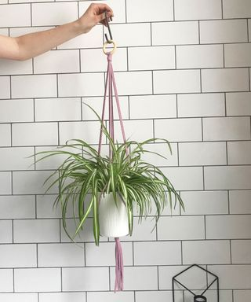
You have made yourself a lovely new plant hanger!

